**Apple’s switch to USB-C iPhones could benefit the entire smartphone ecosystem**

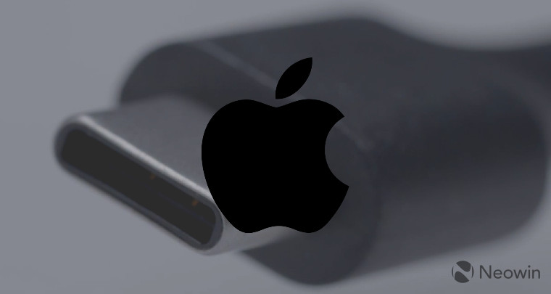

A few weeks ago, reports suggested that Apple might eventually abandon the light port and move on to the future of USB-C. And I cross my fingers hoping this will really happen.

First, Bloomberg and analyst Ming-Chi Kuo have suggested that the iPhone 15 - which will be released next year - will play a USB-C port. Now, a new note from Kuo suggests that some accessories will use this USB charging standard:

Other power(Lightining) port products (e.g., AirPods, Magic Keyboard / Trackpad / Mouse, MagSafe Battery) will also switch to USB-C in the foreseeable future.

It makes sense. If your main device (iPhone) is charged with a USB-C port, you do not want other accessories to charge another port. That would mean carrying more cables. Oops.

Moving to USB-C can have many benefits for Apple. First, it can improve the fast charging of all devices. Most iPhones currently charge 18W-20W, while the Pro Max versions can charge at a much higher price.

Hopefully, USB-C can turn on high speeds, and enable your iPhone to charge faster. As a reference, Xiaomi is currently making a sub- $ 400 phone that is said to be fully charged in 15 minutes.

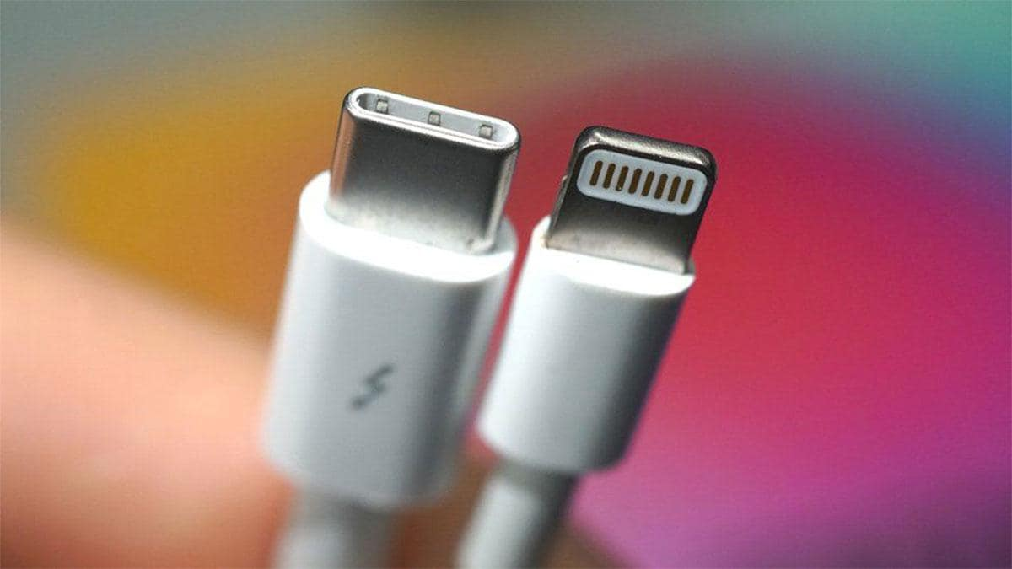

Also, Apple is already using the USB-PD charging standard. So all USB-C to C-certified cables can help with faster charging of iPhones. That means you can use your existing cables, or look at the standard ones on the market.

It is good to think about the future when you can use your old Samsung or Pixel charger to charge your iPhone or AirPods.

Does this mean that Apple may suspend shipping via iPhones? We do not know yet. But we hope that will not be the case at least in the next few years.

Another added benefit of switching to USB-C is data transfer. Currently, Apple uses a standard USB 2.0, with an estimated speed of 480 Mbits per second (approximately 60MB per second). Now, it can run to USB 3.1 or 3.2 and open up data transfers by several gigabytes per second.



Apple is already using USB-C ports to charge and transfer data to MacBooks and iPads. Integrating it on iPhones would be a logical step.

For years, the European Union has been trying to get Apple to use USB-C on iPhones. With this change next year, we can appease the directors and get into their good books. It can be a win-win for everyone.